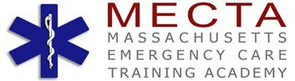

EMERGENCY MEDICAL TECHNICIAN GRADUATING CLASS

FALL 2017

**CONNOR ABERT**

**CHARLOTTE DIAZ**

**MICHAEL GIORGIO**

**LAUREN GERMANO**

**ADAM GONYEA**

**HO GUYEN**

**CHRIS HUMPHREY**

**DAVID KOCH**

**BRANDON MACNEILL**

**EVAN NELSON**

**MORGAN NELSON**

**TYLER PINA**

**JOSEPH SPOSATO**

**JENNIFER TUTTLE**

**SHANNON TUTTLE**

**TIMOTHY WOODFORD**



***The faculty and staff at MECTA Academy wish to congratulate the Academy students for their hard work, determination and dedication to their Teammates and the EMS program.***

***May you enjoy all the rewards of your new career…***

***Life’s a Journey…***