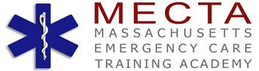

EMERGENCY MEDICAL TECHNICIAN GRADUATING CLASS

FALL 2015

**COLIN JOHNSON**

**FRANK LUDOVICO**

**THOMAS MARSHALL**

**DEVON MCCRILLIS**

**JARED MCMANON**

**HOLLY MORIN**

**JOHN MORO**

**CHRISTOPHER VARNEY**

**MARK WEIMER**

**JOHN CORRIDAN**

**AWTUMN COURVILLE**

**JOSHUA FINNE**

**PHILIP FRANZEN**

**WILLIAM FRINK**

**CHRIS GAGNON**

**MATTHEW HALL**

**JUSTIN HILTZ**



***The faculty and staff at MECTA Academy wish to congratulate the Academy students for their hard work, determination and dedication to their Teammates and the EMS program.***

***May you enjoy all the rewards of your new career.***

***Life’s a Journey…***