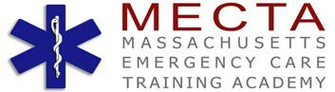
EMERGENCY MEDICAL TECHNICIAN GRADUATING CLASS
SPRING - 2016
The faculty and staff at MECTA Academy wish to congratulate the Academy students for their hard work, determination and dedication to their Teammates and the EMS program.
May you enjoy all the rewards of your new career!
Life’s a Journey…

COREY CARACCIOLO
JAMES CONNORS
LUIS GONZALES
CAILA LAJEUNESSE
ROSS LEMOINE
JOSEPH MULVEY
TREVOR OLSON
TIMOTHY O’MALLEY
JORDYN PHILBROOK
LYDIA ST LAURENT
ADAM THIBAULT
KELLY WRIGHT

