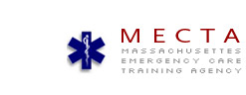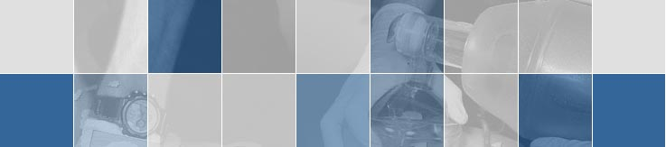Welcome To MECTA, INC.
Emergency Medical Technician Refresher
Online
MECTA E-Learning
Introduction: The Massachusetts Emergency Care Training Academy, MECTA will be offering the EMT Refresher Program in an online format. The course number is EMT 102 and will be offered continuously and will conclude with a mandatory class meeting, (TBA), beginning at 9 AM. This class meeting involves skill station rotations, Automatic External Defibrillator (AED) review and a final written exam, per the Commonwealth of Massachusetts and NREMT regulations.
Course Overview: The Online EMT Refresher is designed to review and update knowledge and skills required to maintain the Commonwealth of Massachusetts and National Registry of Emergency Medical Technicians, EMT certification. The online format is intended to incorporate a flexible schedule tailored to each student's time and/or work availability. The class content is designed to facilitate each student's prior knowledge and experience as an EMT, and it will include a mandatory skills lab. The course is broken down into modules, representing the 1994 US Department of Transportation National Standard curriculum, which will be accessible via the internet.
Course Content: The course site will include a syllabus, content pages, and self-administered review quizzes/exams. This course will qualify you to recertify your EMT-Basic certificate for a two year period. Each student must complete the on-line assignments and quizzes prior to scheduling their CPR, skills evaluation, and post-test session. Students will complete required assignments and take subsequent quizzes on-line. After submission of the assignments and/or quizzes, the students will attend the skills evaluation and post-test session and an optional CPR recertification (dates/times TBA). It must be noted that the student will have up to six (6) weeks to complete all aspects of the course. * No skills classes will be offered the week before Christmas and the last skills session will be on Sunday December 18th at from 9 AM – 2 PM. Location to be determined.
Minimum Computer System Requirements: If your computer is PC compatible it should be at least a Pentium level or better processor with a VGA monitor, and be running Windows 98 or later (however, upgrading may not be a bad idea). If your computer is a MAC, then it should be at least a Power Macintosh or better, running with OS 8.0 or above. You should also need to use Netscape 4.5 (MAC, Windows) or Internet Explorer 5.0 or higher (Windows). A modem connection speed of at least 56 Kps is needed, but the program will work better with higher connection speeds. Additionally, we recommend the following:
- Upgrading your browser to the most current version.
- Discontinue (while using on-line site) any "pop-up ad" blockers. They may block sub-windows such as the homework exams.
- Make sure you have Adobe Acrobat Viewer loaded on your computer. See http://www.adobe.com/products/acrobat/readstep.html for a free download.

Textbook: A textbook purchase is not required for this course, however, the student should have their EMT course textbook available as a reference and or purchase an EMT Refresher text at http://www.emszone.com/emtb/
The online course is designed to be self-guided and will provide considerable content for review. The online course is designed to work with the textbook Emergency care and Transportation of the Sick and Injured, by the AAOS, Jones and Bartlett Publishers. The text is also available for purchase at the link above and includes PowerPoint slides on a CD.
Certification: After successfully finishing this online program, you will receive a MECTA Course Completion certificate. You will need to process a re-certification application with the Commonwealth and/or the NREMT. MECTA does not issue your actual EMT Certificate/Card. There will be additional fees imposed by the Commonwealth and/or National Registry to complete the certification processing. The phone number for DPH/OEMS is (617) 753-7300. Their web site is: http://www.mass.gov/dph/oems/ and the web site for the NREMT is http://www.nremt.org/about/nremt_news.asp

Thank you for your interest in our online EMT Refresher Course. We look forward to meeting you during our practical lab class session at the end of the semester, but in the meantime, please don't hesitate to email us at info@mecta.com if you have any questions. Remember to bookmark this page and check back again in case there have been any changes or updates.

