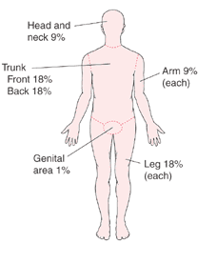
  Estimating the Extent of a Burn
  To determine the severity of a burn, doctors estimate what percentage of the body's surface has been burned. For adults, doctors use the rule of nines. This method divides almost all of the body into sections of 9% or of 2 times 9% (18%). For children, doctors use charts that adjust these percentages according to the child's age (Lund-Browder charts). Adjustment is needed because different areas of the body grow at different rates.

